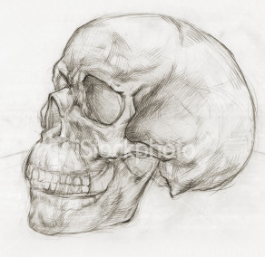
The Skull

Goals for this activity:
- Know all bones and bony features of skull
- Know and be able to identify all four suture of the skull
- Know and be able to identify the foramina and other openings of the skull
- Be able to identify and explain the paranasal sinuses of the skull

BONES OF SKULL

  - Occipital
  - Frontal
  - Parietal
  - Sphenoid
  - Ethmoid
  - Lacrimal
  - Vomer
  - Zygomatic
  - Mandible
  - Maxillae
  - Nasal
  - Temporal
  - Palatine

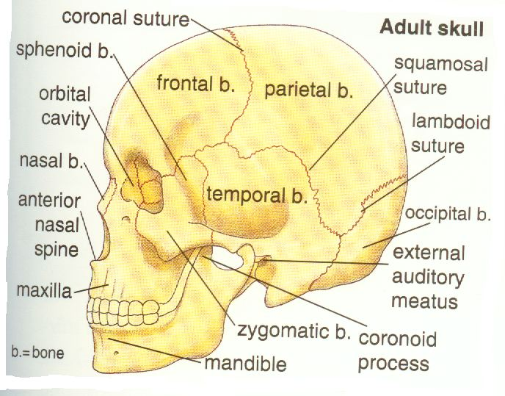

SUTURES OF SKULL

- Lambdoid suture
- Coronal suture
- Sagittal suture
- Squamousal suture
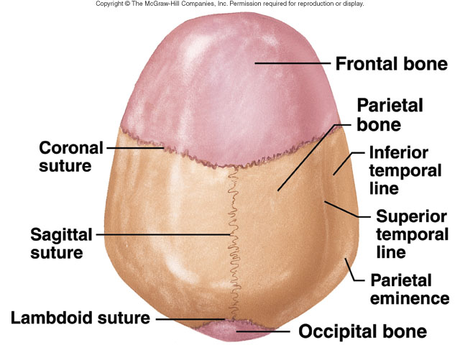

FORAMINA, FISSURES, CANALS OF SKULL (plural of foramen)
- Supraorbital foramen
- Optic foramen/canal (of the sphenoid bone)
- Superior orbital fissure
- Inferior orbital fissure
- Infraorbital foramen
- Mandibular foramen (of the mandible)
- Mental foramen (of the mandible)
- Foramen rotundum
- Foramen ovale
- Carotid canal
- Jugular foramen
- Stylomastoid foramen
- Internal auditory meatus
- Hypoglossal canal
- Olfactory foramina
- External auditory meatus (of the temporal bone)
- Foramen magnum (of the occipital bone)

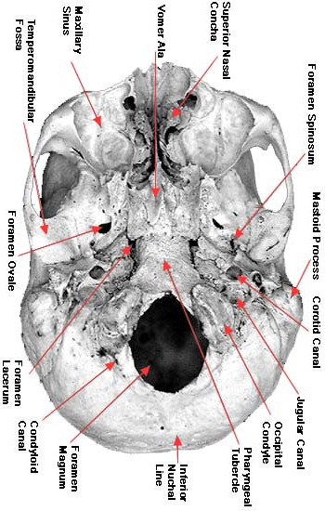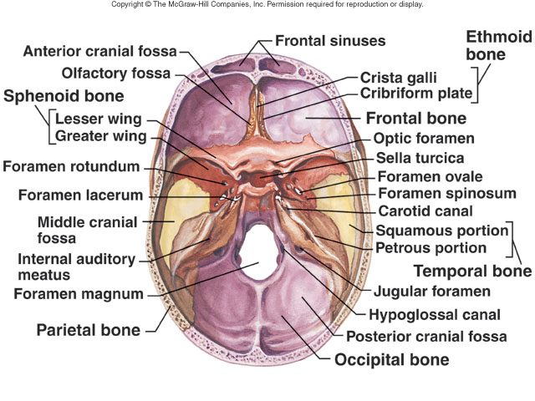

SINUSES OF SKULL
- Maxillary
- Frontal
- Sphenoid
- Ethmoid

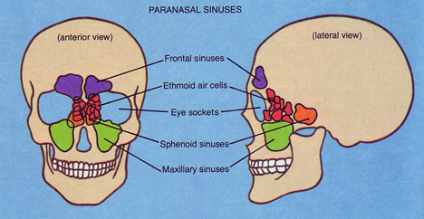

PROCESSES AND OTHER PARTS OF BONES
- Temporal process (of the zygomatic bone)
- Zygomatic process (of the temporal bone)
- Styloid process (of the temporal bone)
- Mastoid process (of the temporal bone)
- External occipital protuberance (of the occipital bone)
- Sella turcica (of the sphenoid bone)
- Cribriform plate (of the ethmoid bone)
- Crista galli (of the ethmoid bone)
- Perpendicular plate (of the ethmoid bone)
- Palatine process (of the maxillae bone)
- Pterygoid process (of the sphenoid bone)
- Occipital condyle (of the occipital bone)
- Mandibular fossa
- Zygomatic arch

- Petrous portion (of the temporal bone)
- Angle (of the mandible)
- Body (of the mandible)
- Ramus (of the mandible)
- Condylar process (of the mandible)
- Coronoid process (of the mandible)

A SUGGESTION: This list is not necessarily very well organized. Maybe it would make more sense to find all the foramina, openings and processes that go with each bone? Make yourself a new list organized that way. Better yet, try to draw each bone, or views of the skull that show all those features, even if they are very schematic…as long as it makes sense to you.



